**Chapter I**

**Introduction**

Garisson Diagnostic Clinic in the Municipality of Hinigaran is using a manual method to record the result and information of their clients. The patient record is respository for information concerning a patient health care records. Despite of the many technological many in the clinics for past few decates, the typical patient record of today interview in the said clinic to gather some information just to minimize the crowded waiting for their time to check-up. The intricate device machinery of our clinic reservation system can no longer grasp the threads of experience for check-up. The Garisson Diagnostic Clinic Reservation System will become an organism guided by misguided patient.

Reservation System improvement could make major contributions to improving the reservation system of the said clinic.

In current’s generation influenced by the high technology just to aiming the good and easy lifestyle and especially in the terms of business. The manual method now is considered as absolute after the computerized system exist. Computerized system is very common in today’s generation to widen the target of the management. It becomes attractive and easy way to the client considering the time to save and also hassle-free to the client.

The most common used by the diagnostic medical clinic is the reservation system creating a website based system. A advanced system in terms of reservation data needed by the clinic to make the matters into the reservation relation that can be easily generate. Reservation system is promote to make the way this system help the clinic to avoid the client’s crowded waiting for the time for their check-up and to full in line.

Having this advanced systematic method on the online check-up reservation to make the management more improve and also convenient by the clinic and to the clients. The online check-up reservation system is meant to help the clinic show to the clients that the management is improving in terms of reserve of schedule of check-up.

The Garisson Clinic Online Reservation System is an automated reserve the schedule to check-up date and time necessary details on the clients by using the website to see the schedule the date and the time.

A Rservation system is a software-based application management use to reserve the client of slot in check-up. The Doctor and client is both can benifits the system that can causing make easy and fast process that cannot use a too much time to waste.

**Purpose and Description**

Garisson Diagnostic Medical Clinic is one of the well-known clinic in the Municipality of Hinigaran the clients are crowded waiting their turn of check-up they full inline in a early of time just to make the first client “first come first serve” rules.

**General Objectives**

This study is aiming to develop the Garizon Diagnostic Medical Clinic by using a website and application just to reservation check-up. To improve this clinic by reservation via online and also to improve their manual way of keeping records.

**Specific Objectives**

1. To develop and help the client to know who is the available doctor..
2. To manage the reservation of the patient.
3. To secure all the information of the patient.
4. To provide help to the patient to lessen the burden of waiting.
5. To develop the reservation flow of the clinic.

**Scope and Limitation of the Research**

The proponents will developed a system in Garisson Diagnostic Medical Clinic in order to provide a convenient way to manage the queuing system of the clinic and also to provide the information of the patient medical records. The Garisson Clinic Online Reservation System involves the reservation of the coming patient in everyday routine of clinic and also the medical records of the patient will be keep in the system and also reduce hours spent retrieving a patient’s records maintain a systematic approach to reserve a slot of the patient waiting for their time to check-up.

**Significance of Study:**

The significance of this research is to implement a system in the Garizon Diagnostic Medical Clinic to have a systematic way of reservation of slot to the patient that will check-up in the clinic and provides a digital form for medical records. The patient can view their reservation number through this system it provide a satisfaction and better service for the patient.

For the **future researcher,** this research will provide them an opportunity to follow some area of interest and make an important contribution to the development of their research to the choosen field.

For the **Garisson Clinic,** this study will serve as a new instrument for technological advancement that will greatly benefiy the clinic.

For the **patient,** they will receive the exact time and date fohr their check-up schedule.

For the **Secretary,** is have a hard time to check the list of the patient. The Secretary will guide the patient where and when their exact schedule.

**Definition of Terms**

This terminologies the group gathered by the researcher for the better and improve the understanding about this study.

**Reservation-** it is the action of reserving the available doctors for the day based on apointment

**Doctor**- in this study, this terms is refers to the one who do the check-up.

**Patient**- in this study, this term refers to someone who reserve a schedule for check-up.

**Record** - it is the list of the patient who reserve and view all patient cases.

**Secretary** - in this study, someone who check the schedule and inform the Doctor who will be the next patient.

**Medical Record-** in this study, refers to the recod of the patient medical history.

**Staff-** it is a group of people who work for an organization.

**Security-** it is the information of patient to keep in private.

**Administration-** in this study refers to the person who is liable for the office maintenance and secure all the things in safety.

**CHAPTER II**

**Review of Related Literature and Prior Arts**

This chapter presents the reviews of related works and studies that deals with online reservation and storing datas. In this research also discuss the related foreign and local literature that is related in this going study.

**Related Concepts**

The proponents conducted a research with the use books and internet to provide related literature and prior arts system that are applicable in the development of the system.

**Related Literature**

**Local Related Literature**

Studies are conducted in the country

**Philippine Field health Service Information System**

Four towns in this province piloted a wireless health system that aims to speed up transmission of patient data thus, improving delivery of medical services. Providing the healthcare of the people in Tarlac is the biggest concern of their goverment. But many people are still unable to get appropriate health service primarily due to the lack of patient information that would help the local health officers to provide the correct medical assistants. Some government institution are working feverishly to develop a system to enable medical professional in he country to get the patient Information and give the correct medical service. Among these is the philippine field health service information system, a project by the department of health in the UP Manila philippine general hospital. The simple goal of this project is to standardize health data collection among medical institutions in the philippines. Just recently, CHITS has been upgraded through a pilot test of a wireless transmission of medical data and reports in rural health units in for rural health units in Tarlac- in the towns of Gerona, Moncada,Paniqui, and Victoria.

**Wireless Access to Health in Tarlac City**

According to Senator Edgardo J. Angara expressed his support for expansion of wireless Access to Health(WAH) in Tarlac province which uses information and communication technology (ICT) in mproving healthcareusing 3G technology.

Angara, Chair of the Congressional Commision on science, Technology and Engineering (COMSTE), lauded the Tarlac Provincial Health office and the department of health (DOH) for successfully implementing the WAHand adding Mobile Midwife and SPASMS (Synchronized Patient Alert via SMS) applications.

“Scaling up WAH can help ensure quality, affordable and accessible healthcare in the philippine. I hope that these projects will all be succeesful, “Angara said.

The WAH is a collaborated public-private partnership established to modernize the access of health workers and doctors to accurate and update patient information by using 3G Wireless technology. It also strengthens the current community health information tracking system (CHITS) which is an electronic medical record system developed by the University or the philippines Manila.

Mobile Widwife enables patient data to be captured and updated electronically to the CHITS system during patient visits via smart phones, tablets or laptop while SPASMS is an alert and health promotion system which sends patients information on prenatal care and child immunization.

**E-Health System of Makati City**

Technology firms are advocating the adoption of electronic health (e-health) technologies to aid local medical practitioners and institutions and to further promote the country as a hub for medical tourism. The adoption e-health in the philippines was set by the department of health (DOH) Secretary Enrique Ona, who has advocated the use of technology to improve healthcare services in the philippines. E-Health is use for various medical practices such as patients records keeping; field emergency responses and database management. Technologies also inprove on the services that are currently delivered by medical institutions. For instance, a doctor can direct a patient to specific medical experts for their conditions via a database of nearby hospitals and clinics. This ensures that patients would get the right treatment. E-Health implementations are already in place in hospitals in Bukidnon, Camiquin, and Davao. E-Health implementations will also take plac in iligan and sultan kudarat. Long-term goals would see technology becoming an important tool in addressing the medical needs of people.

**Foreign Related Literature**

Studies conducted in other country

**School Facility Reservation system(Bonn Rj de Guzman, 2013)**

This project sytem is in the state of development for further improvement both systems can provide a secure field for the information’s and files that are stored in the database. Unauthorized persons can’t access the system. T exixting system is only capable of listing the time when the student will use the facility and what time the student stop. The School facility Reservation System is relevant to the proponents system because It only authorized person can accesss and store data in an online database and can monitor every action of the guard, and administration Only the planters can make resevation, and the system can monitor who is the the person-in-charge of managing the reservation .It consists of reservation list that is decided either to confirm or decline.

**Electric charging station Reservation system and method(Edward D. Tate, JR. Etc,, 2013)**

A method for reserving a vehicle charging station includes receiving a desired destination and authomatically verifying the availability of a designated station at an expected arrival time. The method further includes reserving the designated station is available at the expectted arrival time. The server authomatically verifies the availability of the designated charging station at an expected arrival time at the desired destination. The electric charging ststion reservation system and method is relevant to the proponents system because it can monitor the activities of the personnel of the company that will use the systenm in the future. The proposed system fr reserving the queing includes a server in communication with the application, and with a client device configured for communicating a desired destination to the server through online.

**Online Classroom Reservation System**

The office of the University Registrar is responsible for the reservation of general-use classroom. The On-Line Classroom Reservation System (OCRS) was conceptualized to authomatte the classroom reservation functionand to achieve the following specific objectives are maximising use of staff time, minimizing conflicts in the schedule of classroom us and improving the monitoring of claaroom usage. The online access is limited to the user who uss it, Regardless of the lead time of the cancellation, the classroom could have been reserved and used by others. Th Online Classroom resevation system is relevant to the proponents system because it can be access online and reservation will be declined after 24 hours. The prposed system generaed the account and it secure ever account detail, because it cannot allow unauthorized person to access the application through the input of old password.

**Prior Arts**

**Foreign Prior Arts**

Studies that conducted in ohter country

**Clinic Database and Software Management System (2014)**

Patient record management system in clinic today necessitate competent administration when handling patients, generating reports from the management, patient details which serves as a key factor for the flow of business transaction in St. Francis Hospital Samba. Unfortunately the current record management system leads to misplacement of drug details, payments details, and late release of reports and insecurity to records. This research project is aimed at computerizing all the records about patients, staff and drugs suppliers. In order to achieve this goal, a thorough System study and investigation was carried out and data was collected and analyzed about the current system using documents and data flows diagrams. The concepts of report production have been computerized hence, no more delay in report generation to the hospital manager. Errors made on hand held calculators are dealt out completely. The method used to developed system include iterative waterfall model approach, data flow, logical and entity relationship diagram were used to design the system and finally the language used were MySql, php, HTML, Css and JavaScript.

**Indian Electronic Patient Record System (2015)**

In India, healthcare is one of the largest service sector, with more than 4 million people working in this industry .according to koppar et al 2010, in Indian healthcare sector, pharmaceutical and health insurance services is estimated at U$$ 69 billion at the end of 2015.

The Indian healthcare industry is growing at a phenomenal rate, with private hospitals, government funds and foreign aid in the public health program steering this growth. The combination of high quality service at low cost is also making India a destination. Of health tourism as this mixes fun and leisure with necessary medical attention. The positive effects of all these endeavours is that the life expectancy of an average India has increased, however this is not a reason to be satisfied as figures are still very modest when compared globally (Muckherjee et al.,2010)

On other side, 70 percent of the people live in rural areas and live below the poverty line. They are not able to access quality healthcare, as most of the quality hospitals are located in the cities and towns (Mukherjee et al, 2010). This is one of the reasons for implementing e-governance in healthcare and the use of EPR could be considered a useful starting point.

**Hospital Information System (2011)**

The importance of patient records, also known as medical records, is related to different needs and objectives, as they constitute permanent documents on the health of patients, with the advancement of information technologies and systems, patient records can be stored in databases, resulting in a positive impact on patient care. Based on these considerations, a research question that arisesis “what are the benefits and problem that can be seen with the use of electronic versions of medical records? “ this question leads to the formula of the following hypothesis: although problems can be identified during the process of using electronic record system, the benefits outweigh the difficulties, thereby justifying their use. To respond to the question and test the presented hypothesis a research study was developed with users of the same electronic record system, consisting of doctors, nurses, and administrative personnel in three hospitals located in the city of Sao Paulo. Brazil the results show that, despite some problems in their usage, the benefits of electronic patient record outweigh possible disadvantage.

**Local Prior Arts**

Local conducted in the country

**Online Clinic Reservation System (2012)**

The latest studies have shown a growing demand amongst patient for the ability to look their healthcare appointment online. In this day in age, booking everything from hotels and flights to restaurant reservations all online is commonplace, not to mention convenient. Patients can now gain the same benefits when it comes to booking there medical appointments. The online booking system is also highly favored by hospitals, doctors, dentist and their staff as it saves them substantial time from scheduling appointments and allows them to allocate resources to other, more pertinent areas system and also reduce hours spent retrieving a patients records maintain a systematic approach to reserve a slit of the patient waiting for their time to check-up client.

**Web-based Patient Information System (2013)**

Research describe here was carried out to explore possibilities of creating a web-based patient information system within the areas of thoracic surgery. Data were collected to distinguish and access the actual information needs of patients prior to surgical, before this charge, 8 months after the hospitalization using a fallow-up questioner. Interviews were perform with patient undergoing heart surgery. The study included material of 19 consecutive patient undergoing coronary artery bypass surgery and valve replacement, age 35 to 74, 13 males and 6 female with academic background. Patient satisfaction with given information was high. Analysis of the interviews held at the hospital resulted in seven different categories describing and giving a picture of the patient’s information needs and apprehension receive care. The results found in their design and development process of a health information system.

**Computerized Patient Medical Record (2016)**

The general objective of the study was to developed a computerized patient’s Medical Record System for San Jose hospital and trauma center that would help the hospital in processing and keeping medical record of thier clients. The proposed system was intended to operate in wireless LAN connection as suggested by the clients for they have already resources needed for the application of the said system.

Iterative Life Cycle Model was used to develop the system. Survey results showed that respondents who tried the system gave a positive feedback. In general, the respondents indecated that the entire system is exellent.

The study recommended that the hospital should use Local Area Network (LAN) instead of Wireless Local Area Network (WAN) since there are instances that signals were not clear. The

medical technician and staff are also advised to utillizethe propose system because it is more productive and more capable of delivering quality perfomance. Lastly, future researchers should improve the system by adding other servises offered by the hospital.

**Table of comparison**

The table shows the list of the prior system both forign and local system and different Features that compare on the features of class recording and data storing system.

**Table 1.** Garison Online Clinic Reservation System Feature comparison Table of Related Application and System

|  |  |  |  |  |  |  |
| --- | --- | --- | --- | --- | --- | --- |
| Related prior arts | Features | | | | | |
|  | User- friendly | Connecti-vity | Reservat-ion | Recordi-  ng | Time-  tabling | Security |
| Clinic Database and Software Management System | Yes | Offline | No | Yes |  | No |
| Indian Electronic Patient Record System | Yes | Offline | No | Yes |  | Yes |
| Hospital Information System | Yes | Offline | No | Yes |  | Yes |
| Online Clinic Reservation System | Yes | Online | Yes | No |  | No |
| Web-Based Patient Information System | Yes | Online | No | Yes |  | Yes |
| Computeriz-ed patient’s Medical Record System | Yes | Offline | No | Yes |  | Yes |
|  |  |  |  |  |  |  |
|  |  |  |  |  |  |  |
|  |  |  |  |  |  |  |
|  |  |  |  |  |  |  |
|  |  |  |  |  |  |  |
|  |  |  |  |  |  |  |

**Conclusion**

Table 1 shows the comparison of related application and System, this shows what are the existing applicaton and System that can be compare to develop the project. This includes thier features such as connectivity, Security application, Reservation, Recording.

**CHAPTER III**

**Research Desgin and Methodology**

In this chapter presents the research design and methodology of the proponents system.

**Research Design**

This study is a descriptive - developmental research on the development of web-based Patient and staff reservation and storing datas for Garrison Cinic, Lopez Jaena St. Hinigaran Negros Occidental.

The Agile Scrum Development Cycle is a conceptual model used in online reservation and storing data that descibes the stages involve in an reservation system project from an initial feasibility study through the maintenance of completed application. Agile scrum method emphasizes collaboration, functioning software, team self- management, and flexibility to adopt emerging reservation realities. We used Agile Scrum method as a guide for the process of proponent’s research in developing a system and constructing a software development. Also, this method is the most suitable for our systm.

|  |
| --- |
|  |
|  |

**Table 2. Evaluation Numerical and Descriptive Interpretation**

|  |  |
| --- | --- |
| Numerical Rating | Descriptive Interpretation |
| 5 | Very Good |
| 4 | Good |
| 3 | Average |
| 2 | Fair |
| 1 | Poor |

Table 2 shows the evaluation numerical and descriptive interpretation, 5 for Very Good, 4 for Good, 3 for Average, 2 for Fair, 1 for poor.

**Data Gathering Procedure**

The proponents asked for permission to conduct initial interview and observation on the person in-charge of the Garison Clinic -Lopez Jaena ST. Hinigaran to gather data based on its willingness and availability. Then, the proponents come up with the understanding of the over-all process on how to create an automated bussiness reservation and monitoring.

**Data Analysis**

After the gathering data, the research collected, tallied the scores and applied a statistical treatment such as the statistical mean these scores were then verbally interpreted according to the following range of the scale of statistical mean.

**Table 3.** Statistical Mean and Descriptive Interpretation

|  |  |
| --- | --- |
| Statistical Mean | Descriptive Interpretationl |
| 4.21 - 5.00 | Very Good |
| 3.41 - 4.20 | Good |
| 2.61 - 3 .40 | Average |
| 1. 81 - 2.60 | Fair |
| 1. 00 - 1. 80 | Poor |

Table 3 shows the statistical mean and descriptive interpretation.

**System Development Life Cycle**

The System Development life cycle is a conceptual model used in project management that describes the different stages involved in an information system development project. There are six main phases to create a hardware system only, a software system only or a combination of both to meet or exceed costumers’ expectation. The Scrum software development cycle or the scrum methodology is an iterative and incremental environment. It can also apply to software maintenance project in Scrum the task is divided into as many milestones as possible so that deliverable incremental phases can demonstrated to the costumer much early and hence feedback, problems, issue can be knowing at the easy stage of the project life cycle. Scrum is like a repeated sequence of events milestones and meetings.

**Agile Scrum**

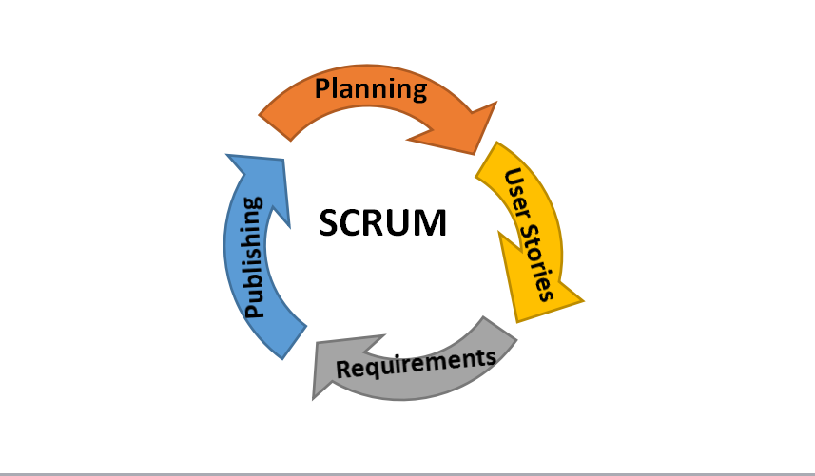

*Figure 1: Agile Scrum Methodology*

Figure 1 The Agile scrum methodology shows on how the process will be develop from planning to publishing. The Agile Scrum is organized that’s why it is easy to use according to the process and will lead to the correct functionality of the system.

The proponents will use this method because on a very simple process it allows to develop work requiring individuals and iterations using a tools documentation extensive patient collaboration. And the Agile Scrum being used more often and frequently will address some patient issues like some mistakes during the reservation of the patient.

**Planning**

In the planning stage the project manager will prepares and manage the schedules of the development of this system. The project manager will be assigning to have a task to each member of the team and they will discuss the procedure and also step up the proposed system. The planning on how to address the problem off the Garisson Clinic will also discussed.

**User Stories**

The proponents already conducted the interview that it will help us to know the features of the users want to the system. In the user stories the proponents also describe the type of user and what they want and why they want that.

**Requirements**

The proponents are already decided of what the system will be needed and the proponents should also provide the requirements that must be easy and accurate and has the capacity to do the features.

**Architectures**

The proponents will design the system presenting a prototype. The proponents will be review the possible changes to implement new properties and some design the implementation process at the end the proponents will decide that there is needed to be change in the design and learn some additional knowledge issues and analysis that possibly appear during the process. The proponents will be exchanging information with the progress, problems and reassigned the changes as required. The decide tools used by proponents to designed the interface of the system is Adobe Photoshop and MS Paint.

**Publishing**

The proponents will conduct a dry run test in the Garisson Clinic to prove that it is reliable. This system will be test before using. Using the Alpha and the Beta testing. During the alpha testing it will verify all the possible issues before the release. And the beta testing the system will be release to the user to know the feedback. This system design to a process currently that yields an immediate result. After testing if it is successful the system will be deploying to use.

**Context Diagram**

The diagram will show how the system will start with the admin(Administrator) who is the person in charge in the system.

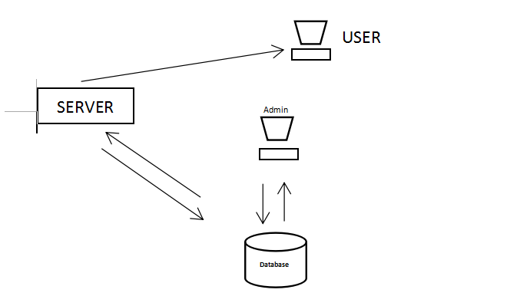

*Figure 2: Context Diagram of Garisson Clinic Online Reservation System*

The patient will be setting a reserve slot to the patient who’s reserving for a check-up and the patient will give a priority number to the patient to know their number. First the patient will input a small information then they have their priority number and also the medical records. The admin also will input it and then it will be stored in the database after the reservation the patient can also view the flow number of the check-up like what number is serving at the moment. And if the patient will ask their medical records the admin will just easily type their name and they can print it easily.

**Data Flow Diagram**

The following data flow diagram shows the process of system.

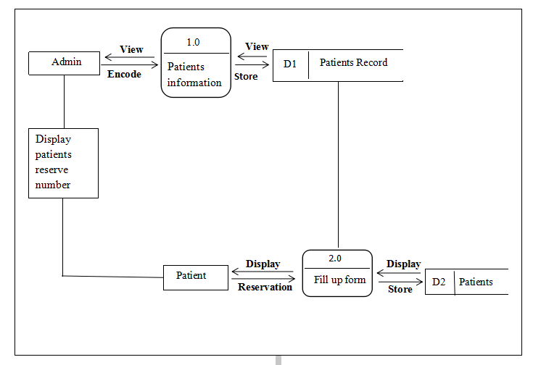

*Figure 3. Data Flow Diagram of the Garrison Clinic Online Reservation System*

**Use Case Model**

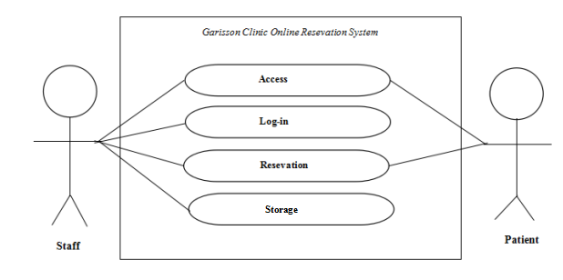

*Figure 4. Use Case Diagram of the Proponents Developed System.*

The corresponding use case descriptions for the above actors are:

**Staff-** Storing the record of the patient that recording the patients medical recordsto the database.

**Patients-** The user who will reserves a slot to check-up.

**Use case descriptions**

Table below describes the function, conditions and alternative flows to be met of the all entities used in the use diagram.

**Table 4: Acces**

|  |  |
| --- | --- |
| **User Case Name** | Access |
| **Primary Actors** | Staff , patients |
| **Description** | Patient and Staff is required to access the website |
| **Pre-Condition** | **Staff -** Must access the website  **Patients-** Must acces the website |
| **Post-conditions** | **Staff -** After accessing the staff is ready to log-in the website  **Patients-** After accesing the website the patient will able to reserve |
| **Main success scenario** | The staff and patient successfully |
| **Alternative flows** | **Staff-** If the staff failed to access the website the staff will not successfully access  **Patient-** If the patient failed to access the website, the patient will not be able to reserve a slot |

**Table 5: Log-in**

|  |  |
| --- | --- |
| **User Case Name** | Log-in |
| **Primary Actors** | Staff |
| **Description** | The staff needs to log-in the website |
| **Pre-Condition** | **Staff -** Must log-in the website |
| **Post-conditions** | **Staff -** After log-in the staff is ready for the transaction with the patient |
| **Stakeholders**  **and Interest** | **Staff-** Responsible to log in the website to continue the transaction |
| **Alternative flows** | **Staff-** If the staff failed to log-in the website the saff will not successfully access the admin section |

**Table 6: Reservation**

|  |  |
| --- | --- |
| **User Case Name** | Resevation |
| **Primary Actors** | Staff, patient |
| **Description** | The staff will give the priority number to the patient |
| **Pre-Condition** | **Staff -** The staff will process the reservation  **Patient-** The patient will asked for resevation |
| **Post-conditions** | **Staff -** The staff will give the priority number to the patient  **Patient-** will give information to the staff |
| **Alternative flows** | If the Staff failed to give the patient a priority number, the patient will not be able to reserve a slot |

**Table 7: Storage**

|  |  |
| --- | --- |
| **User Case Name** | Storage |
| **Primary Actors** | Staff |
| **Description** | The staff store the files in the database |
| **Pre-Condition** | **Staff -** Must record all the files of the patient |
| **Post-conditions** | **Staff -** After recoding, the staff will store it in the database of the system |
| **Stakeholders**  **and Interest** | **Staff-** Responsible to store all the file to the database of the system |
| **Alternative flows** | **Staff-** If the staff failed to record the patient’s medical records, the patient will not be able to save it to the database |

**Activity Diagrams**

The Activity Diagram shows the interactive flow of the activities done by the acor of the developed system.

**Access Activity**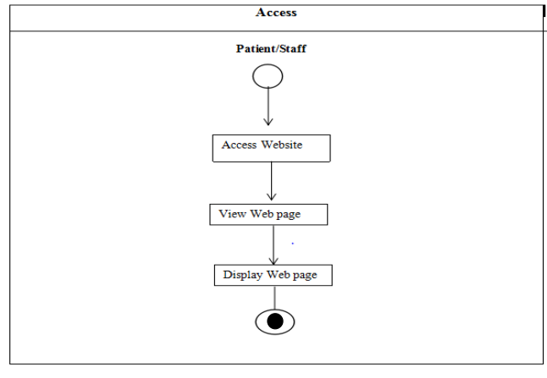

*Figure 5. Access Activity of the Developed System*

Figure 5 shows the steps of patients and staffs accessing the website.

**Log-in Activity**

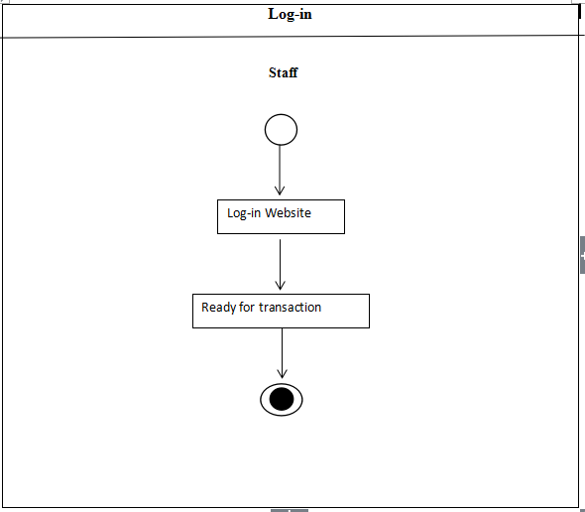

*Figure 6. Log-in of the Staff to the Developed System*

Figure 6 shows the steps of admin/staff ’s loging into the website.

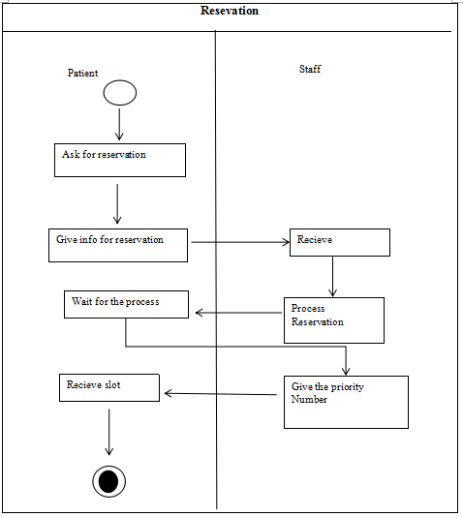**Reservation Activity**

*Figure 7. Reservation Activity of Developed Sytem*

Figure 7 shows the steps reservation online interaction by the staff and patient.

**Storage Activity**

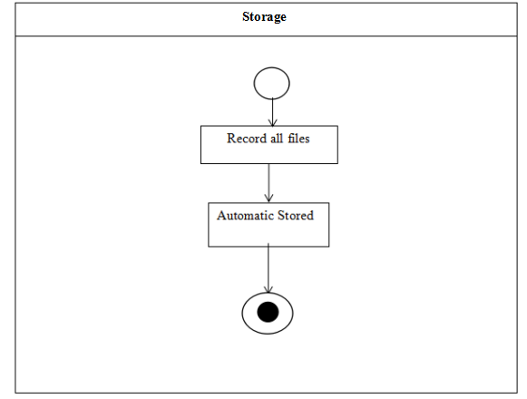

*Figure 8. Store Activity of the Developed System*

Figure 8 shows the steps of storing the data from the user.

**Decomposition Chart**

Decomposition Chart shows th break down process and it’s sub-process of the whole system.

|  |
| --- |
|  |

*Figure 9. Decompisition Chart of Garrison Clinic Online Reservation System*

Figure 9 shows the break down process and its sub process of the developed system. Every process is been labelled and mark to equate functionality of the whol system.

**Operational Frameworks**

**Recommended Hardware Specification**

For the development of Garisson Online Management System the proponents should implements the following hardware specification.

* Monitor
* Mouse
* Keyboard
* 64-bit Processor
* Printer

**Recommended Software Specification**

* Netbeans IDE
* Heidi database
* Heidi utilities

**Entity Relationship Diagram**

Relational Database management system(RDMS) is a database management system (DBMS) based on relation model of data. In comformity, the Entity Relationship Diagram shows the relationship and connection of all tables on the database in working a system.

*Figure 10. Entity Relationship Diagram of the Proponents Developed System*

**Data Dictionary**

The tables below shows the list of all tables and the data stored in the database on the Garrison Clinic Online Reservation System. It provides the attribute, data types and also the description for each fieldnames to recognize the data being stored in the database.

**Table 8: admin**

|  |  |  |  |
| --- | --- | --- | --- |
| **FieldName** | **Description** | **Type** | **Length** |
| user |  | Varchar | 50 |
| Password |  | Varchar | 50 |

**Table 9: medrec**

|  |  |  |  |
| --- | --- | --- | --- |
| **FieldName** | **Description** | **Type** | **Length** |
| **ID_num** |  | **int** | **10** |
| **FirstName** |  | **Varchar** | **50** |
| **LastName** |  | **Varchar** | **50** |
| **Age** |  | **int** | **50** |
| **Gender** |  | **Varchar** | **50** |
| **Address** |  | **Varchar** | **50** |
| **Religion** |  | **Varchar** | **50** |

**Table 10: reserve**

|  |  |  |  |
| --- | --- | --- | --- |
| **FieldName** | **Description** | **Type** | **Length** |
| **ID number** |  | **lnt** | **11** |
| **Name** |  | **Int** | **11** |
| **Address** |  | **Int** | **11** |
| **Gender** |  | **Int** | **11** |
| **Religion** |  | **Int** | **11** |